Induction Week

Name ________________________________________

Period __________________________

Packet due: December 12, 2014

HOW WILL I WRITE MY 3 PARAGRAPH PERSUASIVE ESSAY FOR MY INITITAION INTO_____________________?
(FACTION)
REVIEW:
Fill in the Blank:
H.O.T
H.O.T = which paragraph? ____________________________________________
H = ______________________________________________________________
How many sentences in H? ___________________________________________
O = ______________________________________________________________
How many sentences in O? ___________________________________________
T = _______________________________________________________________
Formula for Thesis Statement? ________________________________________
_________________________________________________________________
How many sentences in T? ___________________________________________

Chapter 37 Questions:
- Why doesn't Tris regret joining Dauntless? (457)

Explain how the quote is significant. What does it reveal about character, theme, or plot? OR a combination of all. AT LEAST FOUR sentences.
Quote | Significance
“You want him to walk?” Caleb demands, “Are you insane?” “Did I shoot him in the leg?” I say. “No. he walks. Where do we do, Peter?” (465) | Write At least FOUR Sentences

- How does Tris' father demonstrate his bravery? (470-471)
REVIEW:
Fill in the Blank:
BODY PARAGRAPH #1, #2, #3
P1 = ____________________________________________________________
P2 = ____________________________________________________________
P3 = ____________________________________________________________
P2 = ____________________________________________________________
P3 = ____________________________________________________________
P2 = ____________________________________________________________
P3 = ____________________________________________________________
P4 = ____________________________________________________________
Chapter 39 Questions:
Explain how the quote is significant. What does it reveal about character, theme, or plot? OR a combination of all. AT LEAST FOUR sentences.
Quote | Significance
“”Tris,” he says, and it's him again. His mouth collides with mine.. “How do you do it?” I say. “I don't know,” he says. “I just heard your voice.”  (478) | Write At least FOUR Sentences

- Why doesn't Tobias kill Tris? (478)

- How do Tris and Tobias try to ensure the simulation can't be restarted? (480)

- Where are they going? (483)

Explain how the quote is significant. What does it reveal about character, theme, or plot? OR a combination of all. AT LEAST FOUR sentences.
Quote | Significance
“I am no longer Tris, the selfless, or Tris the brave. I suppose that now, I must become more than either.” (487) | Write At least FOUR Sentences

- Are they safe yet? Explain. (end)

- Make a prediction about what is going to happen in the next book INSURGENT!! (end)

REVIEW:
Fill in the Blank:
S.T.O.P
S.T.O.P = What paragraph in your essay? _______________________________________
S = ? _________________________________________________________
Formula for S ? ____________________________________________________________
T = ? _________________________________________________________
O = ? _________________________________________________________
How many sentences MINIMUM?___________________________________
P = ? __________________________________________________________
How many sentences? ___________________________________________

Movie Day!!
While watching the movie, write down at least five similarities and five differences between it and the novel we read in class.

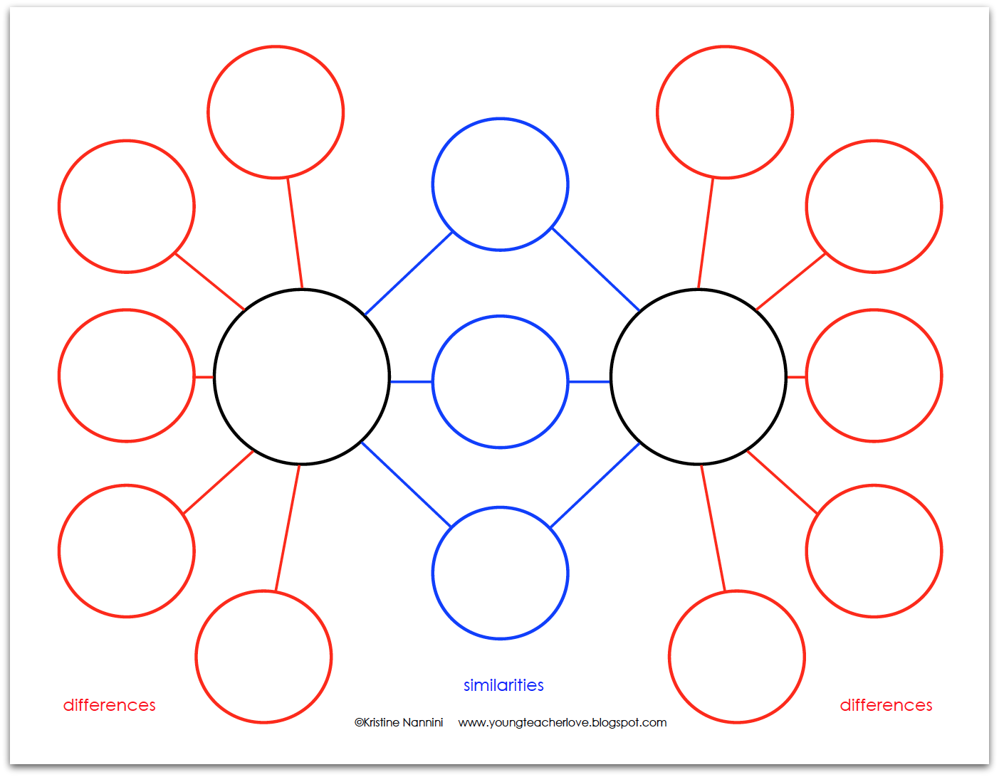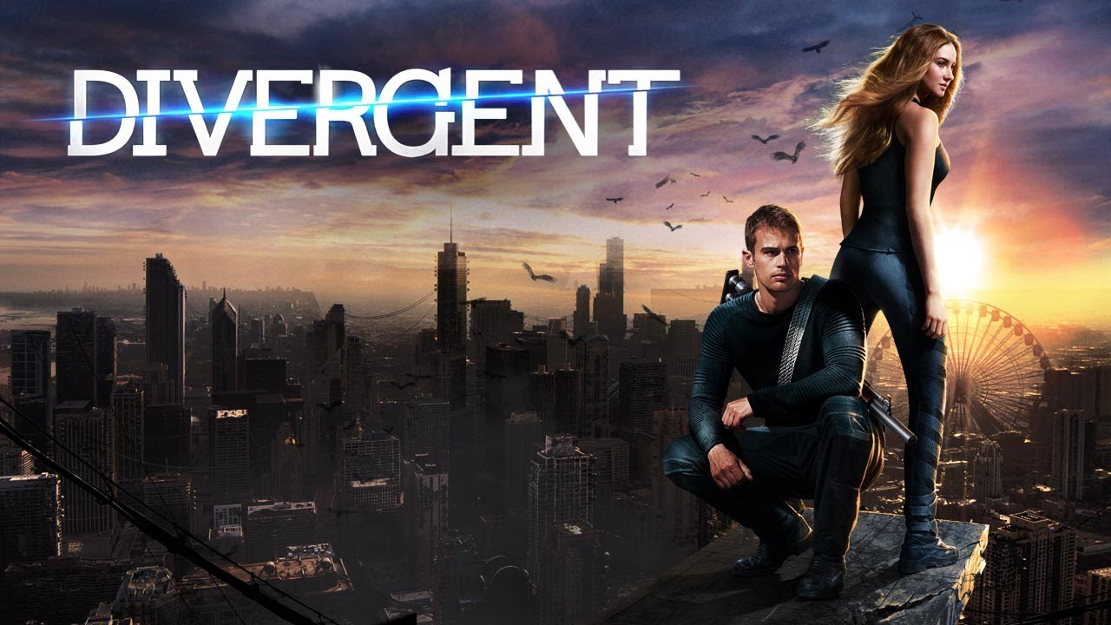

When we are finished watching the movie, we will write a review of it from the perspective of either Tris or Jeanine. You will need details and examples from the movie to write a good review. Imagine that you are in one of the factions, and think about how you would feel about the way your faction was depicted (shown). Use these questions to help you write a good movie review.

- What did you like? Why?
- Briefly explain what was good and bad about the movie.
What parts weren’t good and why weren’t they good?
- Who are the main characters? What is the story about?
- Would you recommend this movie to a friend? Why?
- Do you think the movie was better than the book? Why?
- Summarize the plot (story). Where and when did
it take place?
- Talk about the actors/actresses and discuss who did a
good job and who didn’t. How did the Dauntless act? What about the other factions?
- Do you think the factions (Abnegation, Amity, Candor, Dauntless, and Erudite) were represented fairly?
- What lessons did you learn from this story (theme/moral)? What do you think others will learn from it?
- What group of people would like this movie? Who would you recommend it to? Who would you not recommend it to? What’s the MPAA rating of the movie (G, PG, PG-13, R, etc…)? What is your final word on the film: Is it good or bad?
- RATING SYSTEM: Give the movie a score. You can do grades (A,B,C,D,F+ or -), stars (*** out of *****), numbers (3 out of 5) or something totally original… just don’t use “thumbs up” or “thumbs down.”

What NOT to write: It was a good movie. I liked it. The actors did a good job. Parts of it were kind of cheesy but not too bad. Overall it was fine.
: Movie Review

_____________________________________________________________________________________________________________________________________________________________________________________________________________________________________________________________________
_____________________________________________________________________________________________________________________________________________________________________________________________________________________________________________________________________
_____________________________________________________________________________________________________________________________________________________________________________________________________________________________________________________________________
_____________________________________________________________________________________________________________________________________________________________________________________________________________________________________________________________________
_____________________________________________________________________________________________________________________________________________________________________________________________________________________________________________________________________
_____________________________________________________________________________________________________________________________________________________________________________________________________________________________________________________________________
_____________________________________________________________________________________________________________________________________________________________________________________________________________________________________________________________________
_____________________________________________________________________________________________________________________________________________________________________________________________________________________________________________________________________
_____________________________________________________________________________________________________________________________________________________________________________________________________________________________________________________________________
_____________________________________________________________________________________________________________________________________________________________________________________________________________________________________________________________________
_____________________________________________________________________________________________________________________________________________________________________________________________________________________________________________________________________
_______________________________________________________________________________________

